Ex. No.: 7. SNORT IDS
Aim:
To demonstrate Intrusion Detection System (IDS) using snort tool.
Algorithm:
1. Download and extract the latest version of daq and snort
2. Install development packages - libpcap and pcre.
3. Install daq and then followed by snort.
4. Verify the installation is correct.
5. Create the configuration file, rule file and log file directory
6. Create snort.conf and icmp.rules files
7. Execute snort from the command line
8. Ping to yahoo website from another terminal
9. Watch the alert messages in the log files

Output:
[root@localhost security lab]# cd /usr/src
[root@localhost security lab]# wget https://www.snort.org/downloads/snort/daq-2.0.7.tar.gz

[root@localhost security lab]# wget https://www.snort.org/downloads/snort/snort-
2.9.16.1.tar.gz

[root@localhost security lab]# tar xvzf daq-2.0.7.tar.gz
[root@localhost security lab]# tar xvzf snort-2.9.16.1.tar.gz
[root@localhost security lab]# yum install libpcap* pcre* libdnet* -y
[root@localhost security lab]# cd daq-2.0.7
[root@localhost security lab]# . /configure
[root@localhost security lab]# make
[root@localhost security lab]# make install
[root@localhost security lab]# cd snort-2.9.16.1
[root@localhost security lab]# . /configure
[root@localhost security lab]# make
[root@localhost security lab]# make install
[root@localhost security lab]# snort --version
,,_ -*> Snort! <*-
o" )~ Version 2.9.8.2 GRE (Build 335)
'''' By Martin Roesch & The SnortTeam: http://www.snort.org/contact#team
Copyright (C) 2014-2015 Cisco and/or its affiliates. All rights reserved.
Copyright (C) 1998-2013 Sourcefire, Inc., et al.
Using libpcap version 1.7.3
Using PCRE version: 8.38 2015-11-23
Using ZLIB version: 1.2.8
[root@localhost security lab]# mkdir /etc/snort
[root@localhost security lab]# mkdir /etc/snort/rules
[root@localhost security lab]# mkdir /var/log/snort
[root@localhost security lab]# vi /etc/snort/snort.conf
add this line- include /etc/snort/rules/icmp.rules
[root@localhost security lab]# vi /etc/snort/rules/icmp.rules

alert icmp any any -> any any (msg:"ICMP Packet"; sid:477; rev:3;)
[root@localhost security lab]# snort -i enp3s0 -c /etc/snort/snort.conf -l /var/log/snort/
Another terminal
[root@localhost security lab]# ping www.yahoo.com
Ctrl + C
[root@localhost security lab]# vi /var/log/snort/alert
[**] [1:477:3] ICMP Packet [**]
[Priority: 0]
10/06-15:03:11.187877 192.168.43.148 -> 106.10.138.240
ICMP TTL:64 TOS:0x0 ID:45855 IpLen:20 DgmLen:84 DF
Type:8 Code:0 ID:14680 Seq:64 ECHO
[**] [1:477:3] ICMP Packet [**]
[Priority: 0]
10/06-15:03:11.341739 106.10.138.240 -> 192.168.43.148
ICMP TTL:52 TOS:0x38 ID:2493 IpLen:20 DgmLen:84
Type:0 Code:0 ID:14680 Seq:64 ECHO REPLY
[**] [1:477:3] ICMP Packet [**]
[Priority: 0]
10/06-15:03:12.189727 192.168.43.148 -> 106.10.138.240
ICMP TTL:64 TOS:0x0 ID:46238 IpLen:20 DgmLen:84 DF
Type:8 Code:0 ID:14680 Seq:65 ECHO
[**] [1:477:3] ICMP Packet [**]
[Priority: 0]
10/06-15:03:12.340881 106.10.138.240 -> 192.168.43.148
ICMP TTL:52 TOS:0x38 ID:7545 IpLen:20 DgmLen:84
Type:0 Code:0 ID:14680 Seq:65 ECHO REPLY
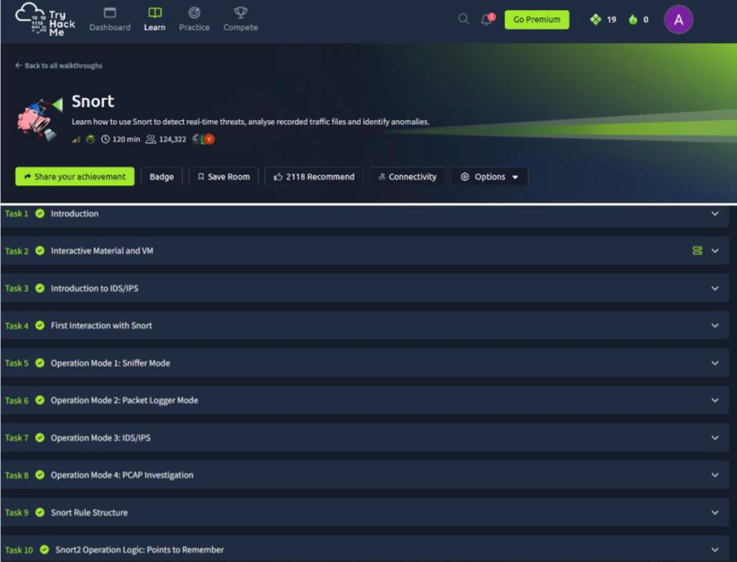
Result: Thus, the Intrusion Detection System (IDS) has been successfully demonstrated using snort.

